 | Huawei eSight For vROps Plug-in
 | User Guide
 | Issue | 03
 | Date | 2019-05-15

 | HUAWEI TECHNOLOGIES CO., LTD. |  | 

Copyright © Huawei Technologies Co., Ltd. 2019. All rights reserved.
No part of this document may be reproduced or transmitted in any form or by any means without prior written consent of Huawei Technologies Co., Ltd.

Trademarks and Permissions
and other Huawei trademarks are trademarks of Huawei Technologies Co., Ltd.
All other trademarks and trade names mentioned in this document are the property of their respective holders.

Notice
The purchased products, services and features are stipulated by the contract made between Huawei and the customer. All or part of the products, services and features described in this document may not be within the purchase scope or the usage scope. Unless otherwise specified in the contract, all statements, information, and recommendations in this document are provided "AS IS" without warranties, guarantees or representations of any kind, either express or implied.
The information in this document is subject to change without notice. Every effort has been made in the preparation of this document to ensure accuracy of the contents, but all statements, information, and recommendations in this document do not constitute a warranty of any kind, express or implied.

Huawei Technologies Co., Ltd.
Address: | Huawei Industrial Base  Bantian, Longgang  Shenzhen 518129  People's Republic of China
Website: | http://www.huawei.com
Email: | support@huawei.com

Preface
Overview
This guide describes how to install and maintain Huawei vRealize Operations Manager (vROps) plug-in.
Intended Audience
This document is intended for:
- Technical support engineers
- System maintenance engineers
Symbol Conventions
The symbols that may be found in this document are defined as follows.
Symbol | Description
 | Indicates an imminently hazardous situation which, if not avoided, will result in death or serious injury.
 | Indicates a potentially hazardous situation which, if not avoided, could result in death or serious injury.
 | Indicates a potentially hazardous situation which, if not avoided, may result in minor or moderate injury.
 | Indicates a potentially hazardous situation which, if not avoided, could result in equipment damage, data loss, performance deterioration, or unanticipated results.  NOTICE is used to address practices not related to personal injury.
Calls attention to important information, best practices, and tips.
NOTE is used to address information not related to personal injury, equipment damage, and environment deterioration.

Change History
Changes between document issues are cumulative. The latest document issue contains all the changes made in earlier issues.
Issue 03 (2019-05-15)
Updated 4 Querying Server Information.
Issue 02 (2018-06-29)
Updated 1 Overview.
Issue 01 (2017-09-07)
This issue is the first official release.
Contents
Preface ii
1 Overview 1
2 Installing and Uninstalling the Huawei vROps Plug-in 3
2.1 Installing the Huawei vROps Plug-in 3
2.2 Uninstalling the Huawei vROps Plug-in 4
3 Configuring an eSight Instance 6
3.1 Adding an eSight Instance 6
3.2 Modifying an eSight Instance 9
3.3 Deleting an eSight Instance 11
4 Querying Server Information 12
4.1 Querying the Server List 12
4.2 Querying Component Information 14
4.3 Adding a Component View 15
4.4 Locating Alert Information 21
5 Querying the Huawei vROps Plug-in Version 24
6 FAQs 25
6.1 Connection Test Failed When Adding an eSight 25

Overview
The Huawei eSight for vROps plug-in is a plug-in integrated in the vRealize Operations Manager software and used for Huawei server management. By adding eSight, it can monitor Huawei servers. The vRealize Operations Manager UIs of different versions are different. In this document, vRealize Operations Manager 6.6 is used as an example.
You can implement the following functions by using the Huawei eSight for vROps plug-in:
- Query server lists.
- Query basic information of server components.
- Query alarm information and health status of servers.
- Table 1-1 lists the servers supported by the Huawei eSight for vROps plug-in.
                - Supported servers
Type | Server
Rack server | RH2288H V2
Rack server | RH1288 V3
Rack server | RH2288 V3
Rack server | RH2288H V3
Rack server | RH5885 V3
Rack server | RH8100 V3
Rack server | 1288H V5
Rack server | 2288H V5
Rack server | 2488 V5
Blade server | CH121 V3
Blade server | CH242 V3
Chassis | MM910
High-density server | XH321 V3
High-density server | XH620 V3
High-density server | XH622 V3
High-density server | XH628 V3
KunLun server | 9008
KunLun server | 9016
KunLun server | 9032

Installing and Uninstalling the Huawei vROps Plug-in
2.1 Installing the Huawei vROps Plug-in
2.2 Uninstalling the Huawei vROps Plug-in

Installing the Huawei vROps Plug-in
            - Download the Huawei vROps plug-in installation package of the latest version from the GitHub website, for example, HuaweieSightManagementPack_X.X.X.pak.
            - On the vRealize Operations Manager WebUI, select Administration.
The Administration page is displayed.
            - In the navigation tree, choose Solutions.
The Solutions page is displayed.
            - Click .
The Add Solution dialog box is displayed.
            - Click BROWSE, and select the plug-in installation file, as shown in Figure 1-1.
            - Select Install the PAK file even if it is already installed., as shown in Figure 1-1.
            - Click UPLOAD, and upload the installation file, as shown in Figure 1-1.
              - Selecting a solution
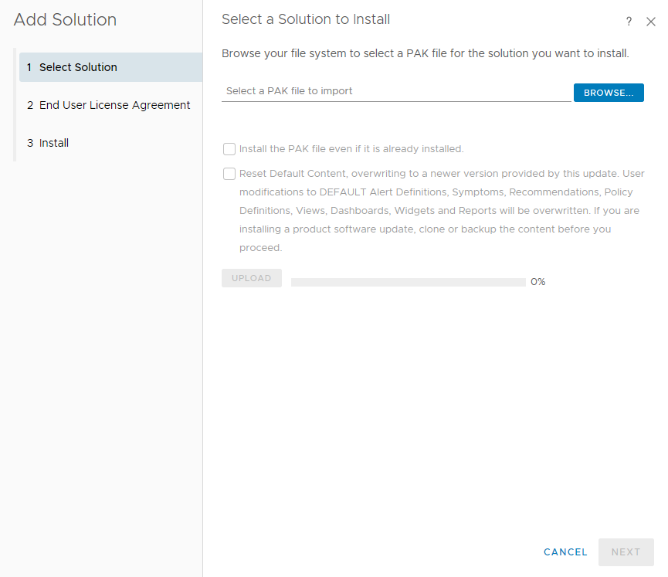

            - Click NEXT.
The Confirmation dialog box is displayed.
            - Click Yes.
The End User License Agreement page is displayed.
            - Select I accept the terms of this agreement, and click NEXT.
The Install page is displayed.
            - After the installation is complete, click FINISH.
On the Solutions page, view the installed Huawei vROps plug-in.
----End

Uninstalling the Huawei vROps Plug-in
            - On the vRealize Operations Manager WebUI, select Administration.
The Administration page is displayed.
            - In the navigation tree, choose Solutions.
The Solutions page is displayed.
            - Select the Huawei vROps plug-in, and click , as shown in Figure 1-1.
              - Uninstalling the Huawei vROps plug-in
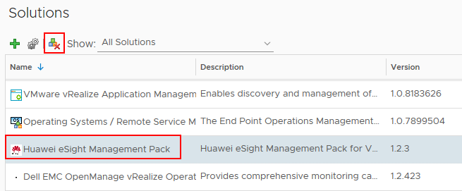

The Warning dialog box is displayed.
The uninstallation of the Huawei vROps plug-in is supported only on vRealize Operations Manager 6.2 and vRealize Operations Manager 6.6. This function is not supported on vRealize Operations Manager of other versions currently.
            - Select I understand the risk and agree., and click OK.
The Huawei vROps plug-in is uninstalled.
----End

Configuring an eSight Instance
3.1 Adding an eSight Instance
3.2 Modifying an eSight Instance
3.3 Deleting an eSight Instance

Adding an eSight Instance
            - Set a whitelist.
By default, a whitelist of eSight northbound ports is configured. To add an eSight system properly, you must add the IP address of the server where vROps is located to the whitelist of eSight northbound ports.
- Log in to the eSight WebUI.
- Choose System > Northbound Integration > Third-party System > Create.
The Third-party System page is displayed, as shown in Figure 1-1.
              - Third-party System
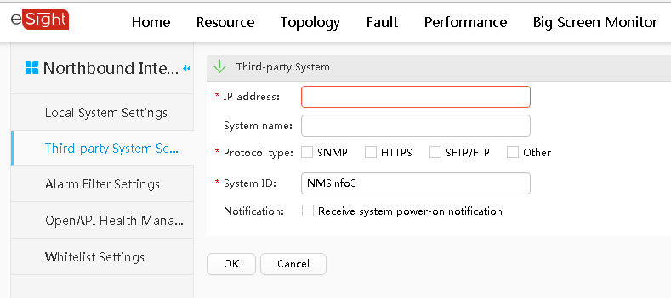

- Set the following parameters:
- IP address: Set this parameter to the IP address of the vROps server.
- Protocol type: Select HTTPS.
- System ID: Retain the default value or enter a new value. The value can be an IP address or a string of 1 to 64 characters, including digits (0-9), lowercase letters (a-z), uppercase letters (A-Z), and special characters @_- (), .^$~`!.
- Click OK.
The IP address of the vROps server is set as a whitelist, as shown in Figure 1-2.
              - Set successfully
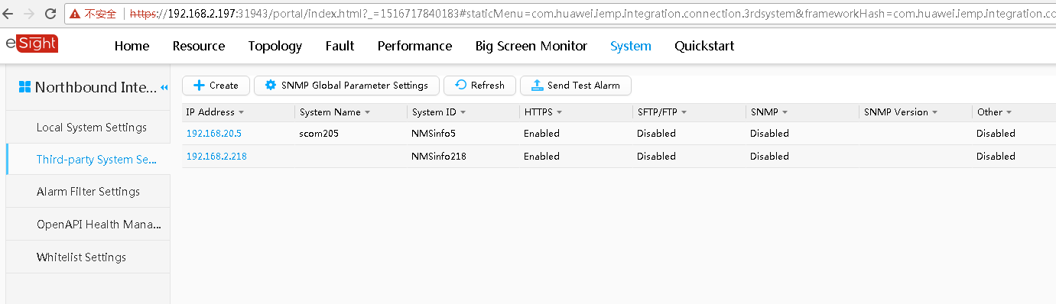

            - On the vRealize Operations Manager WebUI, select Administration.
The Administration page is displayed.
            - In the navigation tree, choose Solutions.
The Solutions page is displayed.
            - Select the Huawei vROps plug-in, and click .
The Manage Solution - Huawei Server Management dialog box is displayed.
            - In the Instance Settings area, set the following parameters, as shown in Figure 1-1.
              - Instance settings
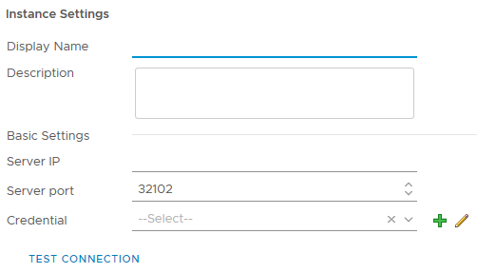

- Display Name: Set this parameter to a customized name. This parameter is used to identify the eSight instance.
- Description: Set this parameter to customized description, which provides supplementary information for the eSight instance.
- Server IP: Enter the eSight IP address.
- Server port: Enter the eSight port number.
            - In the Credential row, click .
The Manage Credential dialog box is displayed.
            - Set the following parameters, and click OK, as shown in Figure 1-1.
              - Manage Credential
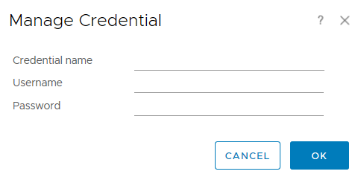

- Credential name: Set this parameter to a customized name. This parameter is used to identify the credential.
- Username: Enter the eSight user name.
- Password: Enter the eSight password.
            - Click TEST CONNECTION.
- If the connection is successful, the dialog box indicating a successful test is displayed.
- If the connection fails, check whether the eSight IP address, port number, user name, and password are correct.
- If no, change the parameter values, and click TEST CONNECTION again.
- If yes, contact Huawei technical support.
            - Click SAVE SETTINGS to save the eSight configuration information.
A dialog box is displayed, indicating that the configuration information is saved successfully.
            - Click OK.
The eSight instance is added.
            - Click CLOSE.
On the Solutions page, view the data collection status of the eSight instance.
----End

Modifying an eSight Instance
            - On the vRealize Operations Manager WebUI, select Administration.
The Administration page is displayed.
            - In the navigation tree, choose Solutions.
The Solutions page is displayed.
            - Select the Huawei vROps plug-in, and click .
The Manage Solution - Huawei Server Management dialog box is displayed.
            - In the navigation tree, select the name of the eSight instance to be modified, and determine whether to modify Basic Settings of the instance, as shown in Figure 1-1.
              - Modifying an eSight instance
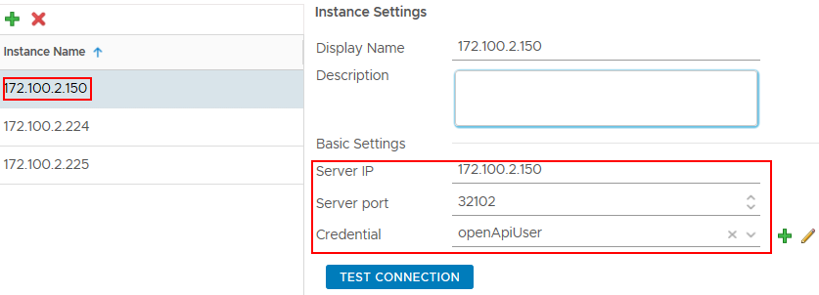

- If yes, perform Step 5 to Step 6.
- If no, go to Step 7.
            - Modify the following parameters, as shown in Figure 1-1.
- Display Name: Change the instance name.
- Description: Change the instance description.
- Server IP: Change the eSight IP address.
- Server port: Change the eSight port number.
- Credential: Click , and change the credential name, eSight user name, and password.
After an eSight instance is accessed, if the eSight port number, user name, or password is changed, you must synchronize the new port number, user name, or password to the vRealize Operations Manager system; otherwise, server management will be affected.
            - Click TEST CONNECTION.
- If the connection is successful, the dialog box indicating a successful test is displayed.
- If the connection fails, check whether the eSight IP address, port number, user name, and password are correct.
- If no, change the parameter values, and click TEST CONNECTION again.
- If yes, contact Huawei technical support.
Then go to Step 8.
            - Modify the following parameters, as shown in Figure 1-1.
              - Instance settings
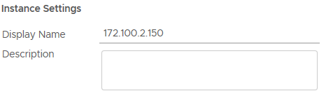

- Display Name: Change the instance name.
- Description: Change the instance description.
            - Click SAVE SETTINGS to save the eSight configuration information.
A dialog box is displayed, indicating that the configuration information is saved successfully.
            - Click OK.
The eSight instance is modified.
            - Click CLOSE.
On the Solutions page, view the data collection status of the modified eSight instance, as shown in Figure 1-1.
              - Collecting data
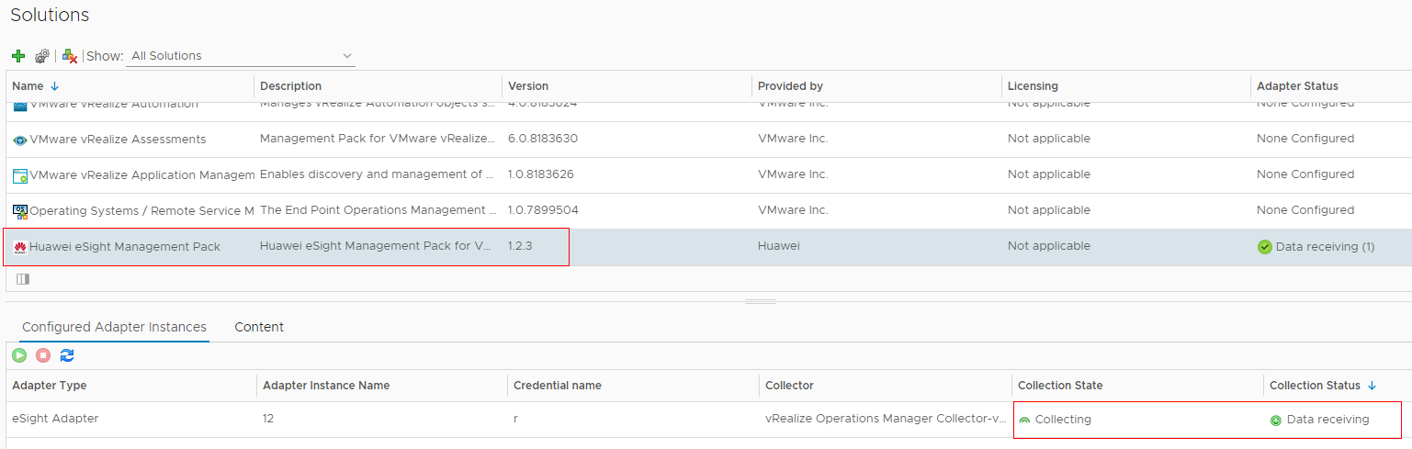

----End

Deleting an eSight Instance
            - On the vRealize Operations Manager WebUI, select Administration.
The Administration page is displayed.
            - In the navigation tree, choose Solutions.
The Solutions page is displayed.
            - Select the Huawei vROps plug-in, and click .
The Manage Solution - Huawei Server Management dialog box is displayed.
            - In the navigation tree, select the name of the eSight instance to be deleted, and click , as shown in Figure 1-1.
              - Deleting an eSight instance
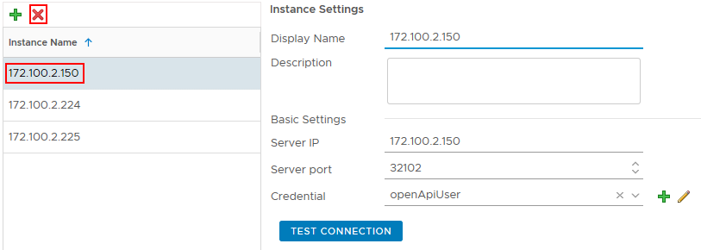

The Confirmation dialog box is displayed.
            - Select Remove related objects. (which is selected by default), and click YES.
The eSight instance is deleted.
----End

Querying Server Information
4.1 Querying the Server List
4.2 Querying Component Information
4.3 Adding a Component View
4.4 Locating Alert Information

Querying the Server List
            - On the vRealize Operations Manager WebUI, select Environment.
The Environment page is displayed.
            - In the navigation tree, choose Huawei Server Management > Device Inventory tree.
The Device Inventory tree page is displayed.
            - In the navigation tree, query the server list, as shown in Figure 1-1.
              - Device Inventory tree
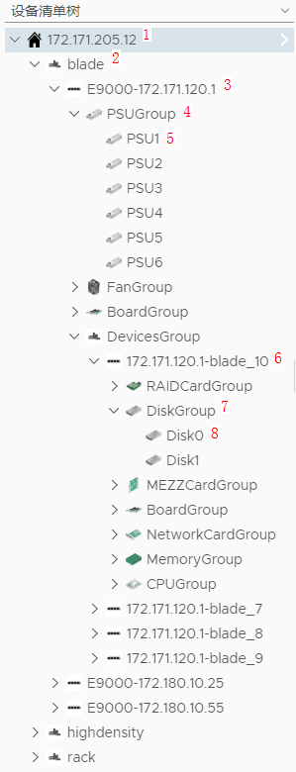

- 1: eSight IP address
- 2: Server type. blade indicates a blade server, highdensity indicates a high-density server, and rack indicates a rack server.
- 3: Server model and iBMC IP address
- 4: Component group
- 5: A component
- 6: IP address and slot number of a management module
- 7: Device group
- 8: A device
----End

Querying Component Information
            - On the vRealize Operations Manager WebUI, select Environment.
The Environment page is displayed.
            - In the navigation tree, choose Huawei Server Management > Device Inventory tree.
The Device Inventory tree page is displayed.
            - Choose eSight IP address > Server type > Server IP address > Component group > Component to be viewed, as shown in Figure 1-1.
              - Component information
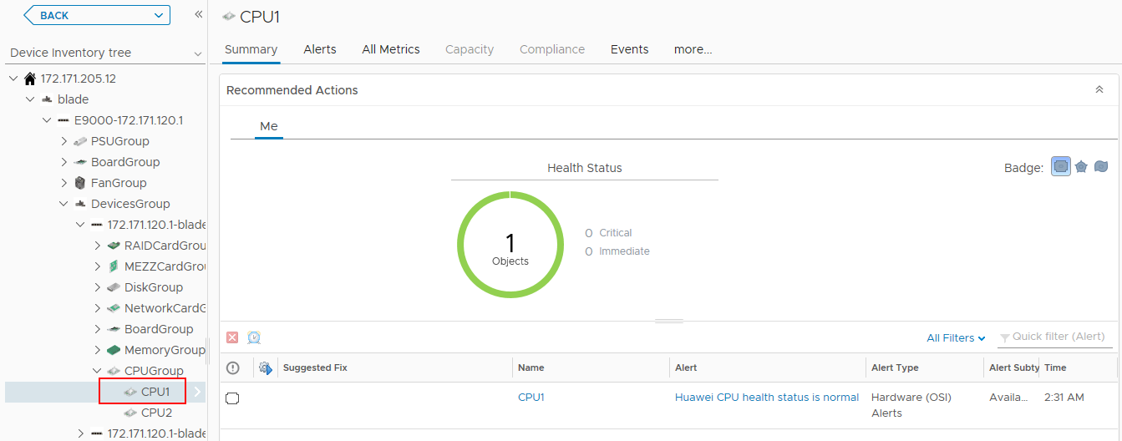

On the Summary tab, the component running status and alarm information are displayed.
            - Click All Metrics.
The All Metrics tab is displayed.
            - Choose All Metrics > Health Status, as shown in Figure 1-1.
              - Health status
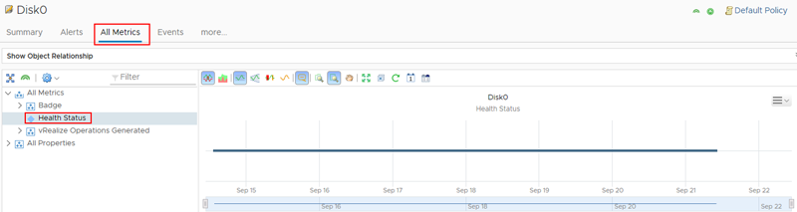

View the real-time status curve chart in the right pane.
----End

Adding a Component View
            - On the vRealize Operations Manager WebUI, select Environment.
The Environment page is displayed.
            - In the navigation tree, choose Huawei Server Management > Device Inventory tree.
The Device Inventory tree page is displayed.
            - Choose eSight IP address > Server type > Server IP address > Component group > Component, as shown in Figure 1-1.
              - Device Inventory tree
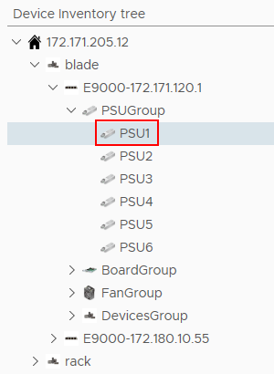

            - In the right pane, click Details.
The Details tab is displayed, as shown in Figure 1-1.
              - Details
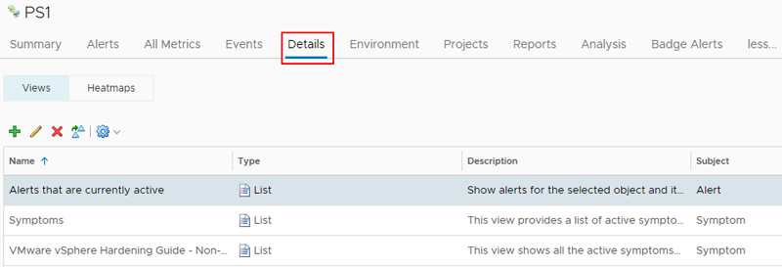

            - Click .
The New View dialog box is displayed.
            - In Name and Description, enter the name and description of the component view to be added.
            - In Presentation, select List, and preview the list in the right pane, as shown in Figure 1-1.
              - Presentation
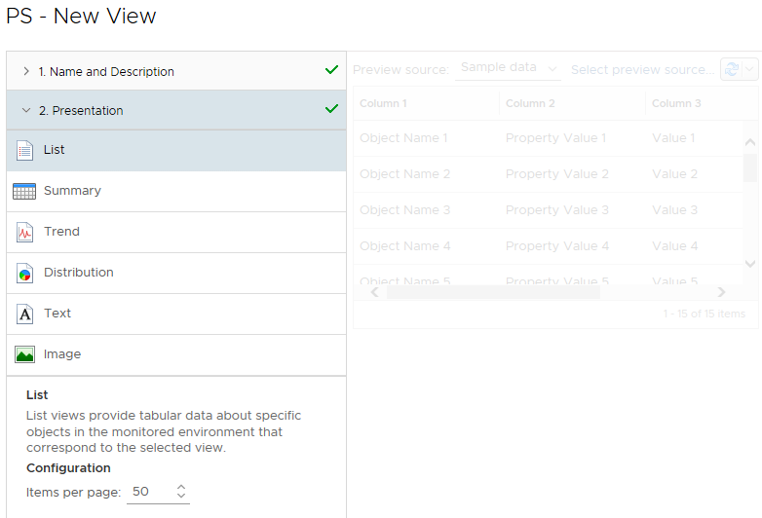

            - In Subjects, choose eSight Adapter > Component type to be added. For example, to add a component view to PS1, choose eSight Adapter > PSU.
            - In Data, select Metrics or Properties, double-click the attribute marked by , and view the newly added attribute in the Data area, as shown in Figure 1-1.
              - Data
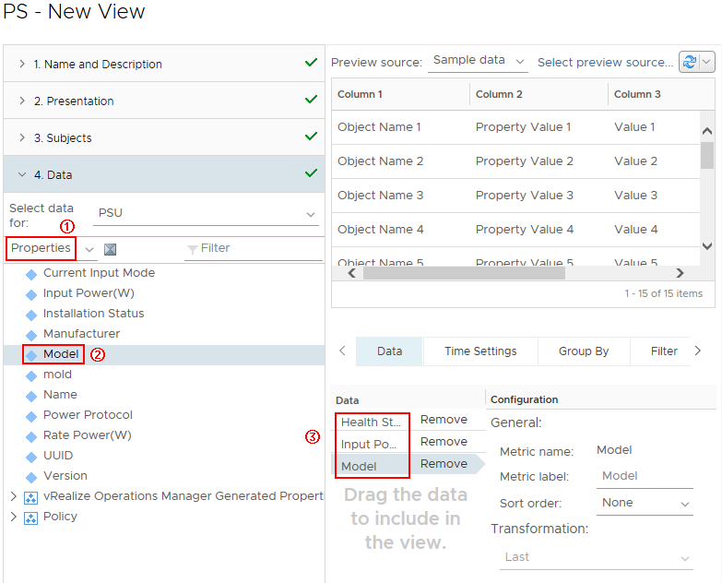

To delete an attribute, click Remove in the Data area. For example, to delete Health Status, click Remove in the Health Status row in (3).
            - In Visibility, retain the default settings, and click SAVE.
On the Details tab, view the newly added component view.
Select Server IP address in Device Inventory tree, choose Details > Newly added component view in the right pane, and view all views of this type of component of the server, as shown in Figure 1-1.
              - View
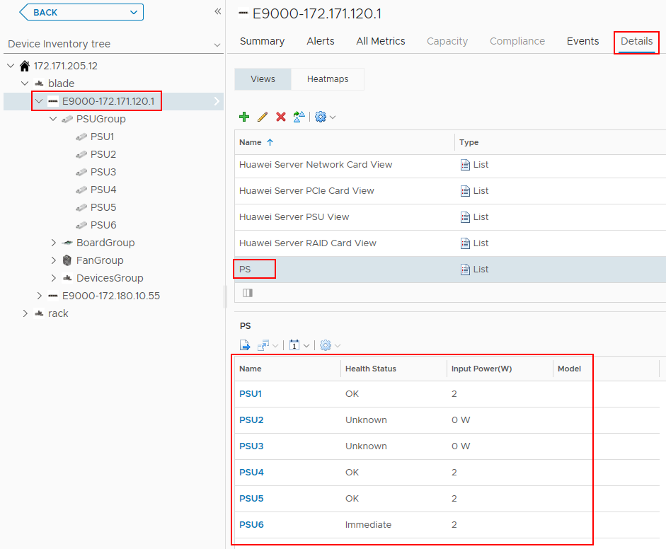

Select Server type in Device Inventory tree, choose Details > Newly added component view in the right pane, and view all views of this type of component of this type of server, as shown in Figure 1-2.
              - View
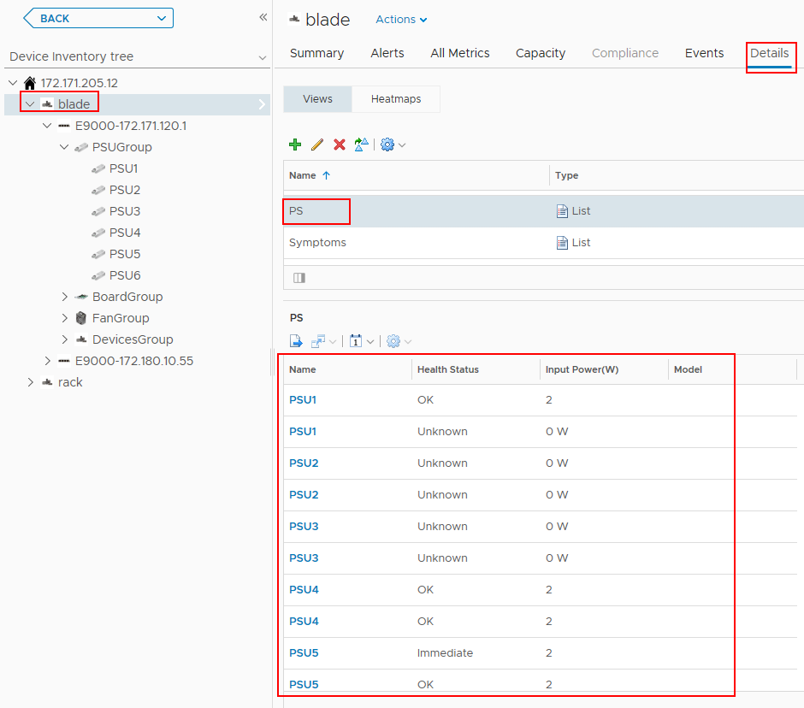

Select eSight IP address in Device Inventory tree, choose Details > Newly added component view in the right pane, and view all views of this type of component of the eSight system, as shown in Figure 1-3.
              - View
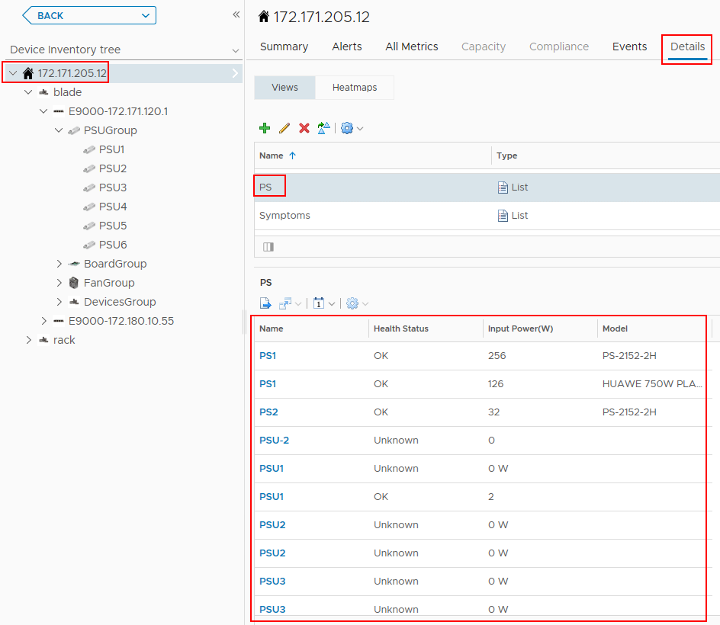

----End

Locating Alert Information
            - On the vRealize Operations Manager WebUI, select Alerts.
The Alerts page is displayed.
            - In the navigation tree, choose All Alerts.
The All Alerts page is displayed.
            - In Group By, select Object Type.
            - In the alarm row of which the component is to be located, click Trigger object, as shown in Figure 1-1.


The trigger object can only be a component and cannot be a component group; otherwise, the server where the alarm is generated cannot be located.
              - All Alerts
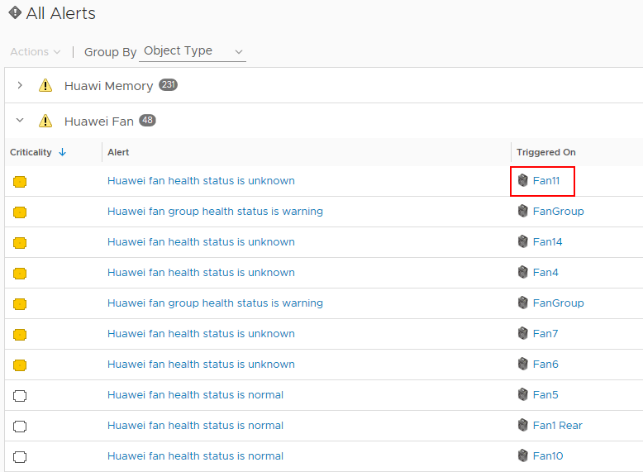

The trigger object information page is displayed, as shown in Figure 1-2.
              - Trigger object
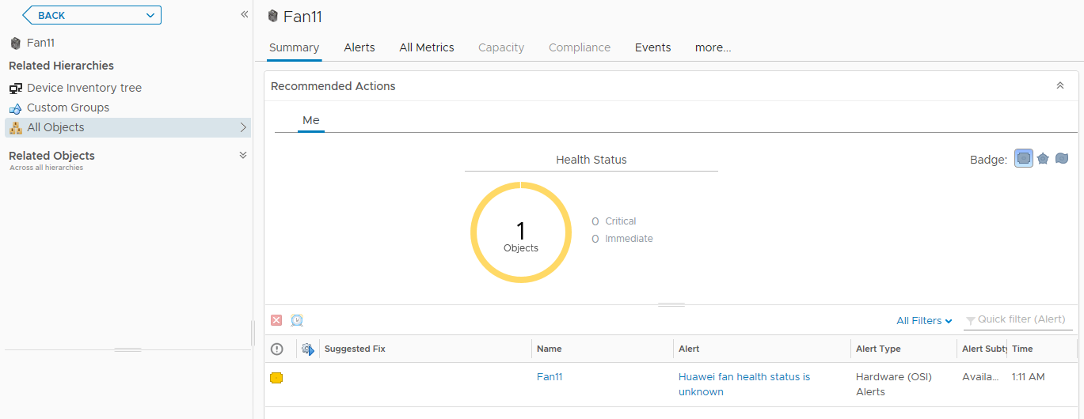

            - In the navigation tree, double-click Device Inventory tree.
The Device Inventory tree page is displayed, as shown in Figure 1-1.
              - Device Inventory tree
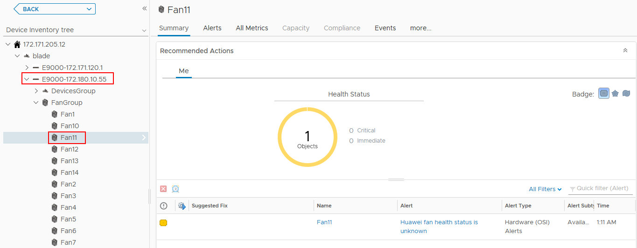

In the navigation tree, view the server to which the trigger object belongs.
----End

Querying the Huawei vROps Plug-in Version
            - On the vRealize Operations Manager WebUI, select Administration.
The Administration page is displayed.
            - In the navigation tree, choose Solutions.
The Solutions page is displayed.
            - View the current Huawei vROps plug-in version, as shown in Figure 1-1.
              - Solutions
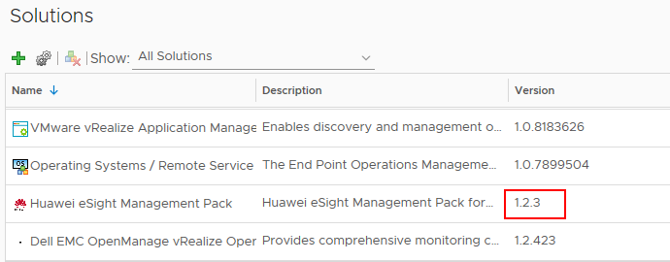
----End

FAQs
6.1 Connection Test Failed When Adding an eSight

Connection Test Failed When Adding an eSight
Symptom
After an eSight server is added, a failure message is displayed during the connection test.
Cause
- The user name or password is incorrect.
- The eSight northbound interface user is locked.
- A whitelist has not been set.
Solution
- The user name or password is incorrect.
Enter the user name and password of the eSight northbound interface user. To view the user name and password, perform the following steps:
  - Log in to the eSight WebUI.
  - Choose System > User Management > User. The User page is displayed.
The role of the eSight northbound interface user is Open API user group, and the user name is displayed under User Name.
              - Viewing information about the eSight northbound interface user

  - Click to display the dialog box for resetting the user password.
              - Reset Password
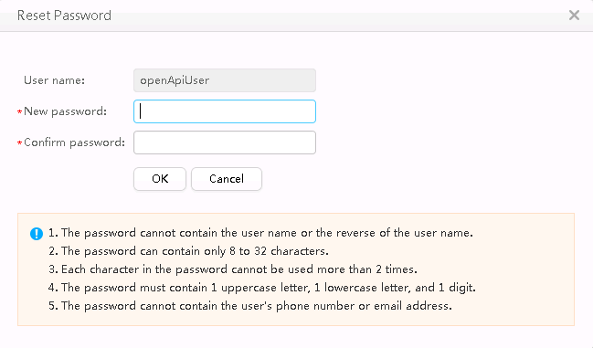

  - Enter a password in New password and Confirm password.
  - Click OK. The password is reset.
- The eSight northbound interface user is locked.
To unlock a user, perform the following steps:
  - Log in to the eSight WebUI.
  - Choose System > User Management > User.
The User page is displayed.
  - Click to set Status of the eSight northbound interface user to Enabled.
              - Unlocking a user

- A whitelist has not been set.
By default, a whitelist of eSight northbound ports is configured. To add an eSight system properly, you must add the IP address of the server where vROps is located to the whitelist of eSight northbound ports.
  - Log in to the eSight WebUI.
  - Choose System > Northbound Integration > Third-party System > Create.
The Third-party System page is displayed, as shown in Figure 1-4.
              - Third-party System

  - Set the following parameters:
  - IP address: Set this parameter to the IP address of the vROps server.
  - Protocol type: Select HTTPS.
  - System ID: Retain the default value or enter a new value. The value can be an IP address or a string of 1 to 64 characters, including digits (0-9), lowercase letters (a-z), uppercase letters (A-Z), and special characters @_- (), .^$~`!.
  - Click OK.
The IP address of the vROps server is set as a whitelist, as shown in Figure 1-5.
              - Set successfully

